Email Online Communication

BY

ABUBAKAR Mohammed JIBRIL
ST/CS/ND/23/004

KABIRU Nasidi
ST/CS/ND/23/021

A SEMINAR PRESENTED TO
THE DEPARTMENT OF COMPUTER SCIENCE,
SCHOOL OF SCIENCE AND TECHNOLOGY, FEDERAL POLYTECHNIC, MUBI ADAMAWA STATE, NIGERIA

JUNE, 2025

Abstract
Email remains a fundamental pillar of online communication, maintaining its relevance in an age dominated by instant messaging and social networking platforms. This seminar article explores the history, evolution, features, advantages, and limitations of email communication, tracing its development from a research tool in the 1970s to a modern, integrated platform supporting professional, academic, and organizational exchanges. The study highlights email's structured format, asynchronous functionality, multimedia capabilities, and role in digital identity and documentation. Despite ongoing challenges such as phishing, spam, and information overload, email continues to evolve through artificial intelligence, enhanced security protocols, and integration with productivity tools. This article further recommends best practices for secure and effective email usage, emphasizing its enduring role in the digital communication ecosystem.

Keywords: Email Communication, Email Features, Asynchronous Communication, Smart Email Systems

Introduction
Email, short for electronic mail, continues to be a vital medium of communication in the 21st century. Despite the rise of social media platforms and instant messaging services like WhatsApp, Telegram, and Slack, email remains the most widely used and trusted online communication tool for formal, academic, and corporate interactions (Radicati Group, 2024). As of January 2024, there are over 4.48 billion global email users, a number projected to surpass 4.73 billion by 2026, reflecting its continued relevance and adaptability in a fast-evolving digital ecosystem (Statista, 2024).
The success and resilience of email lie in its asynchronous communication model, which allows users to send and receive messages without needing both parties to be present simultaneously. This flexibility is particularly crucial in professional and educational settings where coordination across time zones is common. Additionally, email supports structured messaging, including subject lines, greetings, signatures, and attachments, which promotes formality and clarity qualities essential for institutional communication (Chen & Watson, 2023).
Moreover, email has become deeply integrated into modern digital infrastructure. It serves as a gateway to online platforms and services, used for account verification, password resets, transaction confirmations, and more. Tools like Google Workspace, Microsoft Outlook, and Zoho Mail have transformed email clients into productivity hubs, combining email, calendar, document sharing, and task management (Microsoft, 2024).
Despite its advantages, email is not without challenges. Email-based threats, including phishing, malware, and business email compromise (BEC), have increased significantly. According to the 2023 Verizon Data Breach Investigations Report, 36% of breaches involved phishing emails, underlining the critical need for robust email security protocols (Verizon, 2023). Yet, advancements in artificial intelligence and machine learning have significantly improved spam detection, phishing alerts, and auto-responses, enhancing email safety and efficiency (Gartner, 2024).

Literature Review
The history of electronic mail (email) is deeply rooted in the evolution of internet technologies and computer networking. Email was initially developed as a communication method for researchers and engineers working on time-sharing systems and early computer networks. The first recognizable email was sent in 1971 by Ray Tomlinson, a computer engineer working for Bolt, Beranek and Newman (BBN), the company contracted to develop ARPANET—the precursor to the modern Internet. Tomlinson’s innovation included the use of the “@” symbol to separate the username from the host computer name, a convention still used globally today (BBC News, 2021).
Throughout the 1980s, email usage expanded across academic and government networks, primarily in the United States and Europe. Protocols like Simple Mail Transfer Protocol (SMTP), developed in 1982, standardized how email was sent across networks and contributed significantly to its widespread adoption (Kumar & Priya, 2023).
The 1990s marked the commercialization of the internet, making email accessible to the public. This decade saw the emergence of popular web-based email services like Hotmail (1996) and Yahoo Mail (1997). These services offered users the ability to send and receive messages from any internet-connected device, effectively democratizing communication and replacing traditional postal systems for many day-to-day interactions (Radicati Group, 2024).
The launch of Gmail by Google in 2004 revolutionized the email landscape. Gmail introduced 1GB of free storage, a powerful search function, threaded conversations, and spam filters powered by machine learning, setting new standards for user experience and functionality (Google Workspace Updates, 2023). Gmail’s innovations influenced nearly every major email client and contributed to a new era of cloud-based, intelligent communication.
By the 2010s, email became an integral part of both personal and enterprise communication systems. Email was now more than a messaging tool—it evolved into a central hub for digital identity and online activity. It became essential for signing up for services, verifying identities, conducting business, and managing cloud resources.
As of 2024, email remains one of the most used communication tools worldwide, with over 4.48 billion active users, projected to reach 4.73 billion by 2026 (Statista, 2024). With the rise of mobile technology, over 60% of email traffic is now accessed via smartphones, making email a truly mobile-first platform (Litmus, 2023).
Despite the emergence of real-time communication tools such as Slack, Microsoft Teams, and WhatsApp, email has retained its relevance due to its asynchronous, archivable, and formally structured nature. Furthermore, the integration of artificial intelligence (AI) and machine learning algorithms—such as Smart Compose and Smart Reply in Gmail—continues to enhance user experience, automate repetitive tasks, and improve email management (Gartner, 2024).

Features of Email Communication

1. Asynchronous Messaging: One of the most distinctive features of email is its asynchronous nature, meaning that senders and recipients do not need to be online at the same time for communication to occur. This allows individuals to read, process, and respond to messages at their convenience. Such flexibility is especially beneficial in global organizations and educational settings, where communication often spans multiple time zones. According to Gartner (2024), asynchronous tools like email improve productivity by reducing the need for constant, real-time interactions, which can be disruptive and time-consuming.

2. Structured Message Format: Emails are inherently well-structured, providing users with specific fields such as Subject, To, CC (Carbon Copy), BCC (Blind Carbon Copy), and a body section that can be formatted with headers, bullet points, and hyperlinks. This structure encourages clarity and formality, making email the preferred choice for professional and academic communications. The presence of features like read receipts and threaded conversations further enhances communication tracking and organization (Microsoft, 2024).

3. Multimedia and Attachment Support: Another vital feature of email is its ability to support attachments, enabling users to send files such as documents, PDFs, images, spreadsheets, and even video clips. Most modern email services allow attachment sizes ranging from 25 MB to over 100 MB via integrated cloud platforms like Google Drive and OneDrive (Google Workspace, 2023). This makes email a powerful tool for collaborative tasks, project submissions, business proposals, and administrative workflows.

4. Integration with Productivity Tools: Modern email platforms are no longer standalone systems they are deeply integrated with productivity suites. For instance, Google’s Gmail integrates seamlessly with Google Calendar, Google Meet, Docs, and Tasks, while Microsoft Outlook connects with Teams, Word, Excel, and Planner. These integrations enable users to schedule meetings, collaborate on documents, and manage workflows all from within their inbox (Microsoft, 2024). This ecosystem approach transforms email into a centralized productivity hub.

5. Search and Archival Capabilities: One of email’s most useful features is its searchability and archival power. Emails can be stored indefinitely, categorized into folders, or tagged with labels for easy retrieval. Advanced search functions allow users to filter messages by sender, keyword, attachment type, and date, making email a reliable tool for record-keeping and documentation. In corporate environments, archived emails serve as legal records and are often referenced for audits and compliance (Radicati Group, 2024).

6. Spam Filters and Security Protocols: Email platforms today are equipped with intelligent spam filters, which block millions of unwanted and potentially harmful messages daily. Moreover, industry-standard security protocols such as SSL/TLS encryption, Sender Policy Framework (SPF), DomainKeys Identified Mail (DKIM), and DMARC help authenticate emails and prevent spoofing and phishing attacks (Verizon, 2023). These security layers are continuously updated with AI-driven threat detection technologies that adapt to emerging risks in real-time.

7. Personalization and Automation: With the rise of artificial intelligence, email clients now offer features like smart replies, automated responses, priority inbox sorting, and email scheduling. Platforms like Gmail use AI models to suggest context-aware replies or compose emails faster through features like Smart Compose. According to Gartner (2024), AI-driven email automation can increase user response efficiency by up to 30%, significantly boosting productivity in business environments.
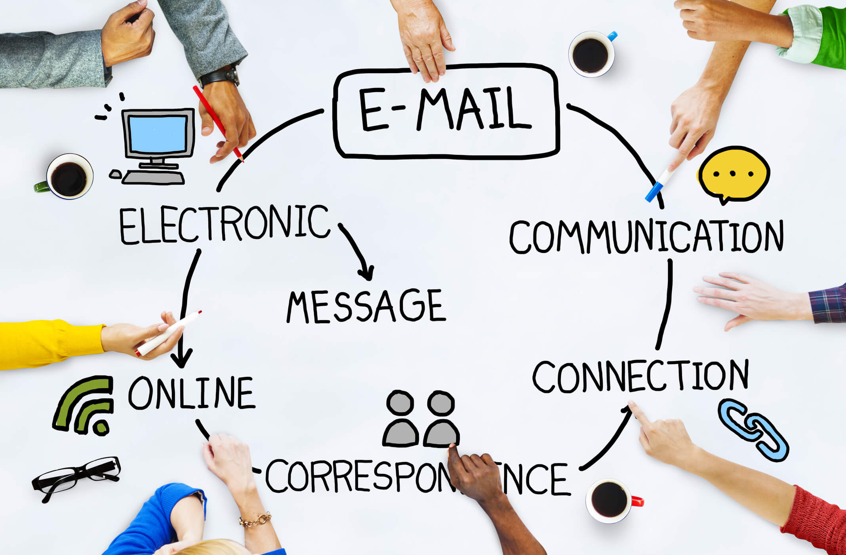
Figure 1: Email communication

Advantages of Email Communication

Cost-Effectiveness: Email remains one of the most cost-effective modes of communication. Unlike traditional postal services or phone calls, sending an email is essentially free, requiring only internet access.

Global Accessibility and Reach: Email can be accessed from anywhere in the world, making it a globally accessible tool. All one needs is a valid email address and an internet-connected device.

Formality and Professionalism: Unlike instant messaging apps, email supports a formal structure that enhances professionalism. With its well-defined components subject lines, salutations, body content, and signatures email is the preferred medium in academic institutions, corporate environments, and government agencies.

Documentation and Record-Keeping: Emails are automatically archived and can serve as legal or professional records. The ability to search through past emails using keywords, dates, or senders allows users to easily retrieve information, track conversations, and maintain accountability.

Attachment and Multimedia Support: Emails allow users to attach documents, images, spreadsheets, presentations, and other media formats. Cloud-based email services like Gmail and Outlook also support sharing large files via integrated platforms such as Google Drive and OneDrive, streamlining collaboration in workplaces and academic institutions.

Integration with Productivity Tools: Modern email platforms are integrated with calendars, task managers, video conferencing apps, and document collaboration tools, turning email into a centralized productivity hub.

Disadvantages of Email Communication

Spam and Unsolicited Messages: One of the most common issues with email communication is the proliferation of spam, which clutters inboxes and can carry malicious links or attachments.

Phishing and Security Threats: Emails are frequently used as vectors for phishing attacks, where cybercriminals deceive users into revealing sensitive information.

Information Overload: The ease of sending emails has led to a situation where many users suffer from email overload, receiving dozens—or even hundreds of emails daily.

Lack of Instant Feedback: Unlike instant messaging platforms or video conferencing, email does not facilitate real-time communication.

Formatting and Deliverability Issues: Emails may not always render correctly across different email clients or devices, leading to formatting issues.

Conclusion
Email remains an indispensable tool in modern digital communication. From its humble beginnings as a messaging platform for computer engineers in the 1970s to its current status as a globally dominant communication medium, email has evolved remarkably in response to technological advancements and user needs. Its structured format, asynchronous nature, and support for attachments make it particularly suited for formal, academic, and professional interactions. Despite the rise of instant messaging applications and collaborative tools, email has not been displaced; instead, it continues to adapt, integrating features such as artificial intelligence for smart replies, enhanced spam filters, and end-to-end encryption to counter security threats. However, challenges such as phishing, spam, and email overload persist and require ongoing attention.

Recommendations
- Organizations and institutions should regularly educate users about email cybersecurity best practices, including how to identify phishing attempts, avoid suspicious links, and use two-factor authentication.
- Users and organizations are encouraged to adopt email management and automation tools such as filters, AI-driven priority inboxes, and smart categorization.
- Institutions, particularly in educational and corporate settings, should teach and enforce email etiquette standards.
- To improve workflow efficiency, it is advisable to integrate email with collaborative tools like Google Workspace, Microsoft Teams, or Slack.

REFERENCES
BBC News. (2021). Ray Tomlinson: The man who put the @ in email. Retrieved from https://www.bbc.com
Chen, L., & Watson, R. (2023). Digital communication preferences in higher education. Journal of Educational Technology, 19(3), 112–120.
Gartner, L. (2024). AI and productivity in digital communication. Retrieved from https://www.gartner.com
Google Workspace Updates (2023). Enhancements in Gmail file attachments and Smart Compose. Retrieved from https://workspaceupdates.googleblog.com
Kumar, R., & Priya, S. (2023). Protocols and architecture of email communication. International Journal of Computer Applications, 182(6), 12–19.
Litmus, K. (2023). Email client market share and user experience report. Retrieved from https://www.litmus.com
Microsoft (2024). Outlook and Microsoft 365 integration features. Retrieved from https://www.microsoft.com
Radicati Group (2024). Email statistics report, 2024–2028. Retrieved from https://www.radicati.com
Statista (2024). Number of email users worldwide from 2017 to 2026. Retrieved from https://www.statista.com/statistics/255080/number-of-e-mail-users-worldwide/
Verizon (2023). 2023 Data breach investigations report. Retrieved from https://www.verizon.com/business/resources/reports/dbir/

